TASK 10
MEASURE AND COMPARE

Program 1
Aim: To count the system calls made by a read()/write() copy program for different buffer sizes using strace -c (file size n = 40,960 bytes).
Program
/ copy.c - copy a file with read()/write() using a chosen buffer size
#include <stdio.h>
#include <stdlib.h>
#include <fcntl.h>
#include <unistd.h>

int main(int argc, char argv[])
{
if (argc != 4) { fprintf(stderr, "usage: %s <src> <dst> <bufsize>\n", argv[0]); return 1; }
size_t b = (size_t)atol(argv[3]);
char *buf = malloc(b);
int in = open(argv[1], O_RDONLY);
int out = open(argv[2], O_CREAT | O_WRONLY | O_TRUNC, 0644);
if (in < 0 || out < 0) { perror("open"); return 1; }
ssize_t n; long total = 0;
close(in); close(out);
fprintf(stderr, "bytes copied = %ld\n", total);
free(buf);
return 0;
}

Commands
head -c 40960 /dev/urandom > in.dat
gcc -o copy copy.c
for b in 1 16 64 512 4096 65536; do
strace -c -e trace=read,write ./copy in.dat out.dat $b
done
Output
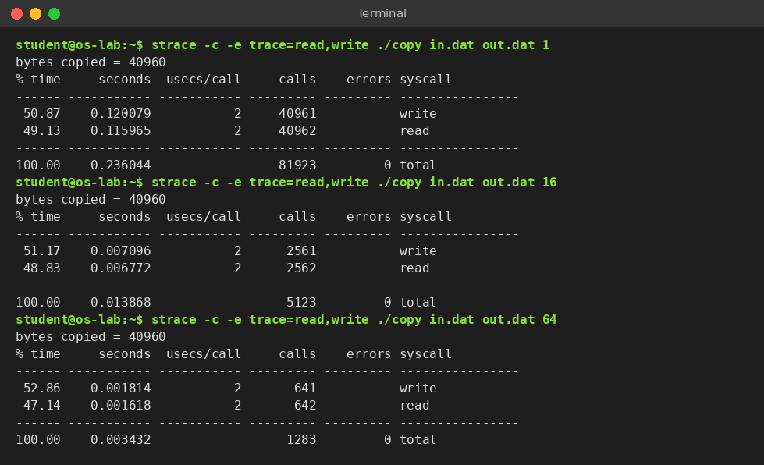
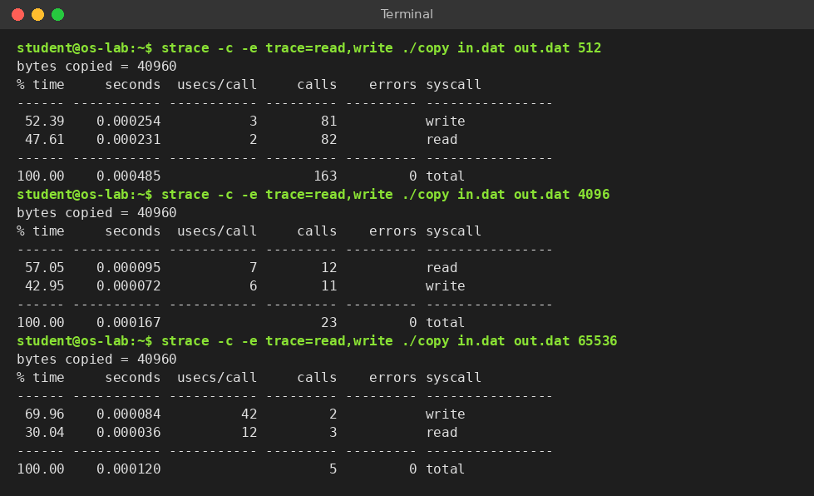
Observation Table (read + write calls)
Buffer size (bytes) | Expected copy calls 2×⌈n/b⌉ | read() measured | write() measured | Total | Extra calls vs expected
1 | 81,920 | 40,962 | 40,961 | 81,923 | +3
16 | 5,120 | 2,562 | 2,561 | 5,123 | +3
64 | 1,280 | 642 | 641 | 1,283 | +3
512 | 160 | 82 | 81 | 163 | +3
4,096 | 20 | 12 | 11 | 23 | +3
65,536 | 2 | 3 | 2 | 5 | +3

Explanation of the difference: every row is exactly 3 calls above the expected value. They are one extra read() that returns 0 at end of file, one read() made by the dynamic loader while it maps the C library, and one write() that prints the “bytes copied” message to stderr. They do not depend on the buffer size.
Result: the number of system calls fell in proportion to the buffer size: 81,923 calls for a 1-byte buffer against 23 calls for 4096 bytes (3,562 times fewer) and only 5 calls for 65,536 bytes. The measured count is ⌈n/b⌉ reads and ⌈n/b⌉ writes plus 3 fixed calls.

Program 2
Aim: To measure the time spent in user mode and in kernel mode while copying a 4,000,000-byte file with different buffer sizes using the time command.
Program
/* the same copy.c of Program 1 is used */
Commands
head -c 4000000 /dev/urandom > big.dat
TIMEFORMAT='real %3R s user %3U s sys %3S s'
for b in 1 16 64 512 4096 65536; do
time ./copy big.dat out.dat $b
done
Output
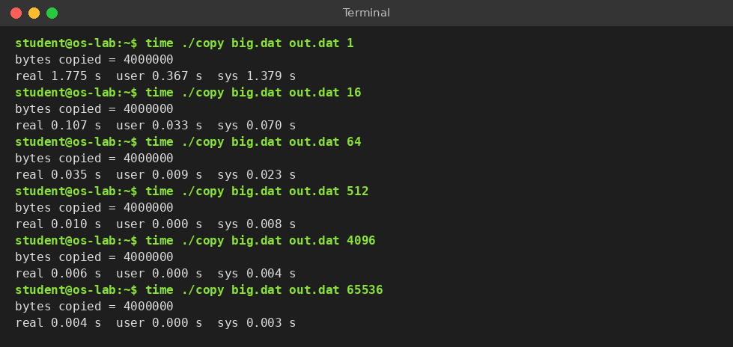
Observation Table (median of 3 runs)
Buffer size (bytes) | System calls ≈ 2×n/b | real (s) | user (s) | sys (s) | Kernel share sys/(user+sys)
1 | 8,000,000 | 1.775 | 0.367 | 1.379 | 79 %
16 | 500,000 | 0.107 | 0.033 | 0.070 | 68 %
64 | 125,000 | 0.035 | 0.009 | 0.023 | 72 %
512 | 15,626 | 0.010 | 0.000 | 0.008 | 100 %
4,096 | 1,954 | 0.006 | 0.000 | 0.004 | 100 %
65,536 | 124 | 0.004 | 0.000 | 0.003 | 100 %

Explanation of the difference: going from a 1-byte to a 4096-byte buffer cuts the system calls by about 4,094 times, but the real time falls only about 296 times (1.775 s to 0.006 s). The cost of moving the 4 MB of data, starting the process and the timer resolution of 1 ms are fixed, so time cannot fall in proportion to the number of calls. From 4096 to 65,536 bytes the calls fall 16 times, yet the time changes by only 2 ms, which is close to the limit of the clock.
Result: with a 1-byte buffer the program spent 79 % of its CPU time in kernel mode (sys 1.379 s, user 0.367 s) because of 8,000,000 mode switches. As the buffer grew, the kernel time fell from 1.379 s to 0.003 s and the program became about 444 times faster in real time.

Program 3
Aim: To measure the time to create 1,000 processes with fork() and 1,000 threads with pthread_create(), with a small parent and with a parent that holds 64 MB of memory.
Program
create.c - time to create N processes (fork) or N threads (pthread_create)
#define _GNU_SOURCE
#include <stdio.h>
#include <stdlib.h>
#include <string.h>
#include <unistd.h>
#include <pthread.h>
#include <time.h>
#include <sys/wait.h>

static double now(void)
{
struct timespec t; clock_gettime(CLOCK_MONOTONIC, &t);
return t.tv_sec1e3 + t.tv_nsec / 1e6;millisecond
}
static void worker(void arg) { return arg; thread does nothing

int main(int argc, char argv[])
{
if (argc != 4) { fprintf(stderr, "usage: %s p|t <count> <heapMB>\n", argv[0]); return 1; }
int n = atoi(argv[2]);
size_t heap = (size_t)atol(argv[3]) << 20;
char mem = malloc(heap ? heap : 1);
memset(mem, 1, heap
pthread_t tid = malloc(n sizeof tid);

double t0 = now();
if (argv[1][0] == 'p') {
for (int i = 0; i < n; i++) {
pid_t pid = fork
if (pid == 0) _exit(0);
waitpid(pid, NULL, 0);
}
} else {
for (int i = 0; i < n; i++) {
pthread_create(&tid[i], NULL, worker, NULL);
pthread_join(tid[i], NULL);
}
}
double t1 = now();
printf("%d %s created and reaped: %.2f ms total, %.2f us each\n", n,
argv[1][0] == 'p' ? "processes" : "threads", t1 - t0, (t1 - t0) 1000.0 / n);
return 0;
}
Output
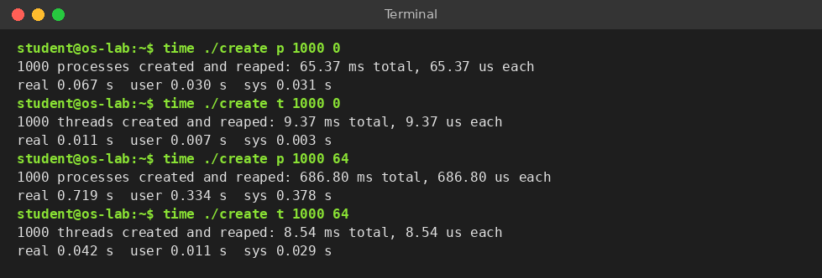
Observation Table (median of 5 runs)
Parent memory | 1,000 fork() total (ms) | fork() each (µs) | 1,000 threads total (ms) | thread each (µs) | fork ÷ thread
small (≈0 MB) | 65.37 | 65.4 | 9.37 | 9.4 | 7.0 ×
64 MB touched | 686.80 | 686.8 | 8.54 | 8.5 | 80.4 ×

Explanation of the difference: fork() must give the child its own address space, so the kernel copies the parent’s page tables and memory-map records and marks every writable page copy-on-write. That work grows with the size of the parent: it rose 10.5 times (65.4 ms to 686.8 ms) when the parent held 64 MB. pthread_create() only allocates a stack and a small kernel record, and the new thread uses the existing address space, so its time did not depend on the parent’s memory (9.4 ms and 8.5 ms).
Result: creating 1,000 threads took 9.37 ms against 65.37 ms for 1,000 processes (7.0 times faster), and the gap widened to 80 times when the parent held 64 MB. Time complexity: fork() costs about O(m) per call for m mapped pages, so N forks cost O(N·m); pthread_create() costs O(1) per call, so N threads cost O(N).

Program 4
Aim: Alternative concept: if threads were created instead of processes, to evaluate the memory used by 1,000 live processes and by 1,000 live threads and to explain the difference by what each one shares.
Program
memuse.c - memory used while N processes or N threads are alive together
#define _GNU_SOURCE
#include <stdio.h>
#include <stdlib.h>
#include <string.h>
#include <unistd.h>
#include <pthread.h>
#include <signal.h>
#include <sys/wait.h>

static long meminfo(const charkey)
{
FILE f = fopen("/proc/meminfo", "r"); char line[128]; long v = 0;
while (fgets(line, sizeof line, f))
if (!strncmp(line, key, strlen(key))) { sscanf(line + strlen(key), " %ld", &v); break; }
fclose(f); return v;
}
static long status(const char file, const char key) value in kB from a /proc file
{
FILE f = fopen(file, "r"); char line[128]; long v = 0;
while (f && fgets(line, sizeof line, f))
if (!strncmp(line, key, strlen(key))) { sscanf(line + strlen(key), " %ld", &v); break; }
if (f) fclose(f); return v;
}
static void worker(void a) { pause(); return a; } thread sleeps

int main(int argc, char argv[])
{
if (argc != 4) { fprintf(stderr, "usage: %s p|t <count> <heapMB>\n", argv[0]); return 1; }
int n = atoi(argv[2]); size_t heap = (size_t)atol(argv[3]) << 20;
sleep(1);
long free0 = meminfo("MemFree:");
long vsz0 = status("/proc/self/status", "VmSize:"), rss0 = status("/proc/self/status", "VmRSS:");
for (int i = 0; i < n; i++) {
if (argv[1][0] == 'p') {
pid[i] = fork();
if (pid[i] == 0) { pause(); _exit(0);
} else pthread_create(&t, NULL, worker, NULL
}
sleep(2);
long free1 = meminfo("MemFree:");
printf("%s x %d, parent heap %ld MB\n", argv[1][0] == 'p' ? "processes" : "threads", n, (long)(heap >> 20));
if (argv[1][0] == 'p') {
long rss = 0, pss = 0;
for (int i = 0; i < n; i++) {
char p[64]; snprintf(p, sizeof p, "/proc/%d/smaps_rollup", pid[i]);
rss += status(p, "Rss:"); pss += status(p, "Pss:");
}
printf("sum of child Rss = %ld kB (counts shared pages again and again)\n", rss);
printf("sum of child Pss = %ld kB (shared pages divided among sharers)\n", pss);
} else {
printf("VmSize: %ld kB -> %ld kB (virtual, stacks reserved)\n", vsz0, status("/proc/self/status", "VmSize:"));
printf("VmRSS : %ld kB -> %ld kB (resident)\n", rss0, status("/proc/self/status", "VmRSS:"));
}
printf("system MemFree used = %ld kB (%.1f kB per %s)\n", free0 - free1, (free0 - free1) / (double)n,
argv[1][0] == 'p' ? "process" : "thread");
if (argv[1][0] == 'p') for (int i = 0; i < n; i++) kill(pid[i], SIGKILL);
return 0;
}
Output
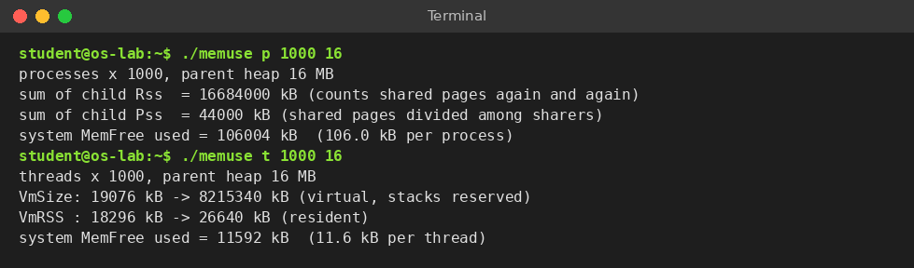
Observation Table (parent heap = 16 MB)
Measurement | 1,000 processes | 1,000 threads
Memory taken from the system (MemFree drop) | 106,004 kB | 11,592 kB
Memory per process / per thread | 106.0 kB | 11.6 kB
Sum of Rss (resident, shared pages counted again) | 16,684,000 kB | one address space: 26,640 kB
Sum of Pss (shared pages divided among sharers) | 44,000 kB | —
Virtual size (VmSize) of the program | 19,076 kB (parent) | 19,076 → 8,215,340 kB

Explanation of the difference: a thread shares the code, the heap, the global data, the open files and the page tables of its process, and owns only its stack, its registers and its thread-local storage. A process shares nothing automatically. Each child gets its own copy of the page tables and memory-map records, its own file table and its own kernel record; the 16 MB heap is shared copy-on-write until a page is written, which is why the Pss sum is only 44,000 kB while the Rss sum looks like 16,684,000 kB. The thread side shows the opposite effect: each thread reserves an 8 MB stack, so the virtual size grew by about 8,196,264 kB, but only the touched pages become real memory.
Result: 1,000 processes used 106,004 kB of system memory (106.0 kB each) and 1,000 threads used 11,592 kB (11.6 kB each), so a process cost about 9.1 times more than a thread. Threads are cheaper because they share the address space; they cost more only in reserved virtual address space (8 MB of stack each).

Comparison with Earlier Judgements
Aim: To check whether the measurements support or contradict the expectations made before the experiments.
Earlier judgement (expected) | Measured | Verdict | Reason for any difference
System calls ≈ n/b for read and for write | 81,923 calls at b = 1; 5 calls at b = 65,536 | Supported | Exactly 3 fixed extra calls (EOF read, loader read, stderr write)
Small buffers spend most time in kernel mode | sys = 79 % of CPU time at b = 1 | Supported | Each call is a user/kernel mode switch
Larger buffer is always proportionally faster | 4096 → 65,536 bytes: 0.006 s → 0.004 s despite 16× fewer calls | Partly contradicted | Fixed data-copy and start-up cost dominates; clock resolution is 1 ms
fork() is slower than creating a thread | 7.0 × slower (small parent) | Supported | fork() builds a new address space
Thread creation does not depend on parent size; fork() does | fork 65 → 687 ms; thread 9 → 9 ms | Supported | Page tables are copied for a process, shared by threads
Threads use less memory than processes | 11.6 kB against 106.0 kB each | Supported for real memory; contradicted for virtual memory | Threads reserve 8 MB virtual stack each; summing Rss overstates process memory

Result: the measurements supported the main judgements (call count ∝ 1/buffer size, kernel time dominates for tiny buffers, processes cost more than threads in time and memory). Two judgements needed correction: the speed-up from larger buffers flattens after about 4 KB, and threads use more virtual but less real memory than processes.

